***Soft Men's Scarves***

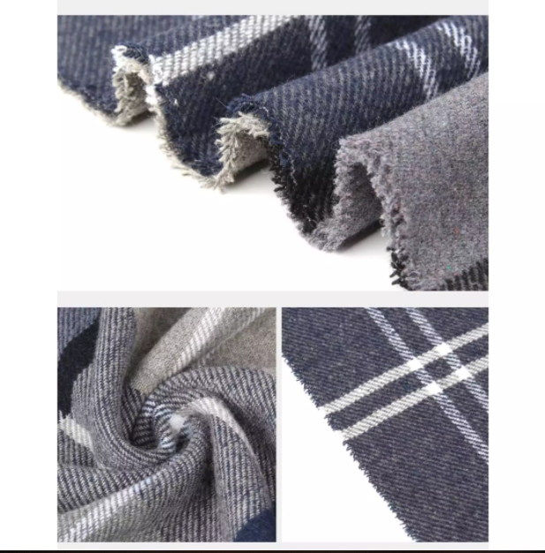

*Not only has the effect of keeping warm, woolen scarves are also a way to tone and create a more impressive style for the wearer. - A very thick and smooth scarf is a more meaningful gift than your words of love in the cold winter. - Luxurious and sophisticated, extreme western color never goes out of fashion. - Wide scarf has many unique styles or becomes a very luxurious shawl. - The fleece material is soft, smooth, and keeps warm well - Suitable for both Men and Women, can make couple and group clothes. Scarves are easy to wear, easy to coordinate with many styles, suitable for everyone – Scarves Meaningful gifts for relatives and friends*